Requirements Document
PPE Compliance Detection System
Team: 6
Team Lead:- Srikara Karthikeya
Scrum Master:- Raajitha
Business Owner:- Deekshitha
Product Owner:- Usha
Developer:- Akaash

1. Introduction
1.1 Purpose
The PPE Compliance Detection System is an AI-powered computer vision application designed to improve workplace safety by automatically monitoring workers through live CCTV camera feeds. The system detects whether workers are wearing the required Personal Protective Equipment (PPE), such as hard hats, safety vests, gloves, goggles, and masks. It also identifies fall incidents and immediately notifies safety personnel. The primary objective is to reduce workplace accidents, improve regulatory compliance, and replace manual safety inspections with an automated real-time monitoring solution.
1.2 Scope
The system processes live video streams from CCTV cameras and performs real-time object detection using the YOLOv8 deep learning model. It detects workers, identifies PPE compliance or violations, and generates instant alerts whenever a safety violation or fall is detected. All detection events are stored in MongoDB for future reference and reporting. The application also provides an interactive dashboard for monitoring live feeds, viewing historical records, generating reports, and managing cameras and users.

2. System Overview
The PPE Compliance Detection System consists of several integrated modules that work together to provide real-time safety monitoring.
- Live CCTV Video Streaming
- Video Frame Processing
- YOLOv8 Object Detection Engine
- PPE Compliance Detection
- Fall Detection
- Alert Management
- MongoDB Database
- Streamlit Dashboard
- User Authentication and Role Management
The system continuously analyses incoming video frames, detects PPE violations, stores event information, and displays alerts through an easy-to-use dashboard.

3. Functional Requirements
The system shall provide the following functionalities:
Live Video Monitoring
- Connect to CCTV cameras using RTSP.
- Display live video streams.
- Process multiple camera feeds simultaneously.
PPE Detection
The system shall detect:
- Person
- Hardhat
- Safety Vest
- Gloves
- Goggles
- Mask
- Ladder
- Safety Cone
PPE Violation Detection
The system shall identify:
- No Hardhat
- No Safety Vest
- No Gloves
- No Goggles
- No Mask
Fall Detection
The system shall detect worker falls in real time and generate emergency alerts.
Alert Management
Whenever a violation or fall is detected, the system shall:
- Capture a snapshot.
- Record the event.
- Display a dashboard notification.
- Optionally send email or SMS alerts.
Historical Records
The system shall maintain searchable detection logs based on:
- Site
- Camera
- Date
- Violation Type
- Worker Area
Dashboard
The dashboard shall provide:
- Live camera feeds
- Detection overlays
- Active alerts
- Detection history
- Reports
- Camera management
- User management
Reporting
The system shall generate reports including:
- Violations by type
- Violations by site
- Violations by camera
- Daily and weekly summaries
- Exportable reports

4. Non-Functional Requirements
Performance
- Real-time detection using YOLOv8.
- Alert latency should be less than five seconds.
- Support multiple concurrent camera streams.
Reliability
- System uptime should be at least 99%.
- Continuous monitoring without interruption.
Scalability
The system should allow new cameras, users, and construction sites to be added without requiring architectural changes.
Security
- Passwords shall be securely stored.
- Role-Based Access Control (RBAC) shall be implemented.
- Only authorised users can access system resources.
Usability
The dashboard shall be user-friendly, responsive, and accessible from desktops, tablets, and mobile devices.

6. Technology Stack
Component | Technology
Programming Language | Python 3.10+
Frontend | Streamlit
AI Model | YOLOv8
Deep Learning Framework | PyTorch
Computer Vision | OpenCV
Database | MongoDB Community Server
Database GUI | MongoDB Compass
Database Driver | PyMongo
Reporting | Plotly
Version Control | GitHub
5. System Architecture
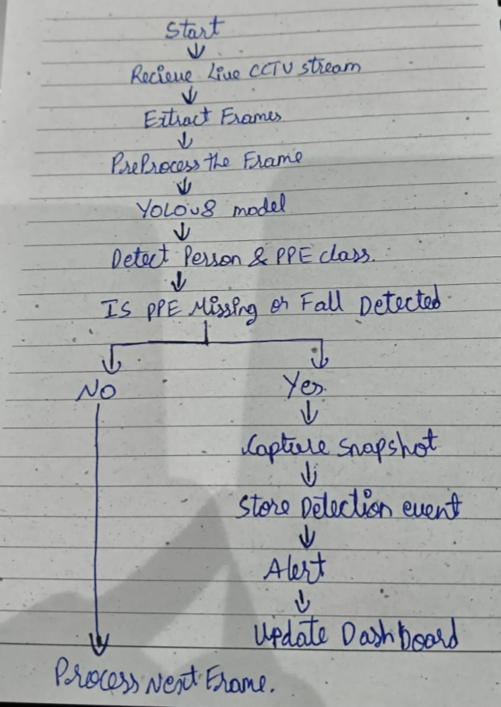

8. Assumptions and Constraints
Assumptions
- CCTV cameras are already installed.
- A stable network connection is available.
- The YOLOv8 model is trained using the provided PPE dataset.
- MongoDB Community Server is installed locally.
Constraints
- Face recognition is not included.
- Worker identity tracking is outside the project scope.
- Camera installation is not part of this system.
- PPE quality assessment is not supported.

10. Conclusion
The PPE Compliance Detection System provides an intelligent, automated solution for monitoring workplace safety using artificial intelligence and computer vision. By combining YOLOv8, OpenCV, Streamlit, and MongoDB, the system enables real-time detection of PPE violations and fall incidents, instant alert generation, centralised monitoring, and comprehensive reporting. This solution enhances worker safety, improves regulatory compliance, and reduces the need for manual inspections.

